Data Transformation

Case Study -1(CS 15)

- Extract data from the given SalaryGender CSV file and store the data from each column in a separate NumPy array

import numpy as np
import pandas as pd
import os
import matplotlib.pyplot as plt

print (os.getcwd())

os.chdir ('C:\\Noble\\Training\\Case Studies\\Case Studies with Answer\\CS 15 Ans -Data Transformation-1\\')

print (os.getcwd())

df = pd.read_csv('SalaryGender.csv')
display (df)

salary = np.array(df['Salary'])
display (salary)

gender = np.array(df['Gender'])
display (gender)

age = np.array(df['Age'])
display (age)

phd = np.array(df['PhD'])
display (phd)

- Find:

  - The number of men with a PhD

  - The number of women with a PhD

df = pd.read_csv('SalaryGender.csv', delimiter=',')
salary = np.array(df['Salary'])
gender = np.array(df['Gender'])
phd = np.array(df['PhD'])
age = np.array(df['Age'])

men_count = 0
women_count = 0

for i in range(0, 100):
if gender[i] == 1 and phd[i] == 1:
men_count +=1
if gender[i] == 0 and phd[i] == 1:
women_count +=1

print('Men Count', men_count)
print('Woman Count',women_count)

- Use SalaryGender CSV file. Store the “Age” and “PhD” columns in one DataFrame and delete the data of all people who don’t have a PhD

df = pd.read_csv('SalaryGender.csv', delimiter=',')
salary = np.array(df['Salary'])
gender = np.array(df['Gender'])
phd = np.array(df['PhD'])
age = np.array(df['Age'])

frame = pd.DataFrame()
frame["Age"] = age
frame["PhD"] = phd

for i in range(0, 100):
if frame.loc[i]["PhD"] == 0:
frame = frame.drop(i)
print('Number of records',len(frame))
print(frame)

- Calculate the total number of people who have a PhD degree from SalaryGender CSV file.

df = pd.read_csv('SalaryGender.csv', delimiter=',')
phdcount=0

for i in range(0, 100):
if df.iloc[i]['PhD'] == 1:
phdcount=phdcount+1

print('PhD Count:',phdcount)

- How do you Count The Number Of Times Each Value Appears In An Array Of Integers?

[0, 5, 4, 0, 4, 4, 3, 0, 0, 5, 2, 1, 1, 9]

Answer should be array([4, 2, 1, 1, 3, 2, 0, 0, 0, 1]) which means 0 comes 4 times, 1 comes 2 times, 2 comes 1 time, 3 comes 1 time and so on.

arr = np.array([0, 5, 4, 0, 4, 4, 3, 0, 0, 5, 2, 1, 1, 9])

print(np.bincount(arr))

- Create a numpy array [[0, 1, 2], [ 3, 4, 5], [ 6, 7, 8],[ 9, 10, 11]]) and filter the elements greater than 5.

Array

Our array is:
[[ 0 1 2]
[ 3 4 5]
[ 6 7 8]
[ 9 10 11]]

Result

The items greater than 5 are:

[ 6 7 8 9 10 11]

import numpy as np
x = np.array([[ 0, 1, 2],[ 3, 4, 5],[ 6, 7, 8],[ 9, 10, 11]])
print('Our array is:' )
print(x)
print('\n')

# Now we will print the items greater than 5
print('The items greater than 5 are:' )

print(x[x > 5])

- Create a numpy array having NaN (Not a Number) and print it.

array([ nan, 1., 2., nan, 3., 4., 5.])

Print the same array omitting all elements which are nan

import numpy
a = numpy.array([numpy.nan, 1,2,numpy.nan,3,4,5])
print(a)
print(a[~numpy.isnan(a)])

- Create a 10x10 array with random values and find the minimum and maximum values.

import numpy as np
Z = np.random.random((10,10))
print (pd.DataFrame(Z))

Zmin, Zmax = Z.min(), Z.max()
print ('Min and Max Values')
print(Zmin, Zmax)

- Create a random vector of size 30 and find the mean value.

import numpy as np
Z = np.random.random(30)
m = Z.mean()
print(m)
- Create numpy array having elements 0 to 10 And negate all the elements between 3 and 9

Array
[ 0 1 2 3 4 5 6 7 8 9 10]

Negeted Array
[ 0 1 2 3 -4 -5 -6 -7 -8 9 10]

import numpy as np
Z = np.arange(11)
print ('Array')
print (Z)

Z[(3 < Z) & (Z <= 8)] *= -1
print ('Negeted Array')
print(Z)

- Create a random array of 3 rows and 3 columns and sort it according to 1st column, 2nd column or 3rd column.

<< Z[:,1].argsort() This statement sort based on column and return the index of each sorted value

Argsort - Returns the indices that would sort an array >>

Z = np.random.randint(0,10,(3,3))
print(Z)
print ()

print(Z[Z[:,1].argsort()])

- Create a four dimensions array (2,2,2,2) get sum over the last two axis at once.

Four Dimension Array
[[[[9 4]
[9 8]]

[[1 3]
[5 3]]]

[[[9 8]
[5 4]]

[[8 6]
[5 0]]]]
Result

[[30 12]
[26 19]]

A = np.random.randint(0,10,(2,2,2,2))
print ('Array')
print (A)

sum = A.reshape(A.shape[:-2] + (-1,)).sum(axis=-1)
print ('Result')
print(sum)

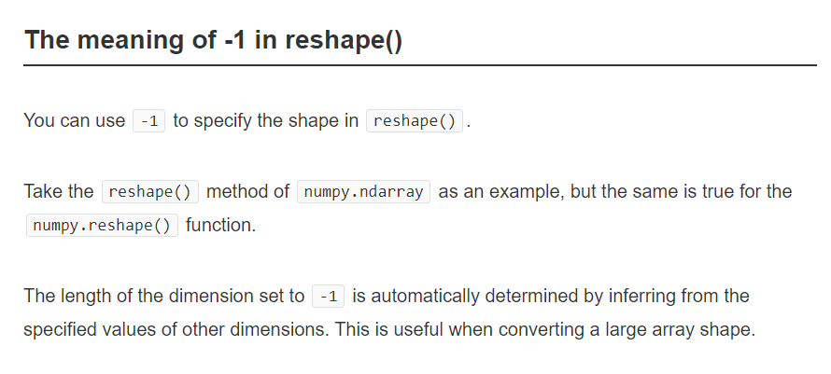

- Create a random array ( 5,5) and swap two rows of an array.

Random Array
[[ 0 1 2 3 4]
[ 5 6 7 8 9]
[10 11 12 13 14]
[15 16 17 18 19]
[20 21 22 23 24]]

Swapped Array
[[ 5 6 7 8 9]
[ 0 1 2 3 4]
[10 11 12 13 14]
[15 16 17 18 19]
[20 21 22 23 24]]

A = np.arange(25).reshape(5,5)
print ('Random Array')
print (A)
# First row assigned to Zeroth row and zero row assigned to first row

A[[0,1]] = A[[1,0]]
print ()
print ('Swapped Array')
print(A)

- Analyse various school outcomes in Tennessee using pandas. Suppose you are a public school administrator. Some schools in your state of Tennessee are performing below average academically. Your superintendent, under pressure from frustrated parents and voters, approached you with the task of understanding why these schools are under-performing. To improve school performance, you need to learn more about these schools and their students, just as a business needs to understand its own strengths and weaknesses and its customers. Though you is eager to build an impressive explanatory model, you know the importance of conducting preliminary research to prevent possible pitfalls or blind spots. Thus, you engages in a thorough exploratory analysis, which includes: a lit review, data collection, descriptive and inferential statistics, and data visualization.

Phase 1 - Data Collection

Here is a data of every public school in middle Tennessee. The data also includes various demographic, school faculty, and income variables. You need to convert the data into useful information.

- Read the data in pandas data frame (middle_tn_schools.csv)

- Describe the data to find more details

import pandas as pd
df = pd.readf = pd.read_csv("middle_tn_schools.csv")

display (df.describe())

Phase 2 - Group data by school ratings

Chooses indicators that describe the student body (for example, reduced_lunch) or school administration (stu_teach_ratio) hoping they will explain school_rating. reduced_lunch is a variable measuring the average percentage of students per school enrolled in a federal program that provides lunches for students from lower-income households. In short, reduced_lunch is a good proxy for household income.Isolates ‘reduced_lunch’ and groups the data by ‘school_rating’ using pandas groupby method and then uses describe on the re-shaped data

display(df[['reduced_lunch', 'school_rating']].groupby (['school_rating']).describe().unstack())

Phase 3 – Correlation analysis

Find the correlation between ‘reduced_lunch’ and ‘school_rating’. The values in the correlation matrix table will be between -1 and 1. A value of -1 indicates the strongest possible negative correlation, meaning as one variable decreases the other increases. And a value of 1 indicates the opposite.

display(df[['reduced_lunch', 'school_rating']].corr())

Phase 4 – Scatter Plot

Find the relationship between school_rating and reduced_lunch, Plot a graph with the two variables on a scatter plot. Each dot represents a school. The placement of the dot represents that school's rating (Y-axis) and the percentage of its students on reduced lunch (x-axis). The downward trend line shows the negative correlation between school_rating and reduced_lunch (as one increases, the other decreases). The slope of the trend line indicates how much school_rating decreases

as reduced_lunch increases. A steeper slope would indicate that a small change in reduced_lunch has a big impact on school_rating while a more horizontal slope would indicate that the same small change in reduced_lunch has a smaller impact on school_rating.

import pandas as pd
import matplotlib.pyplot as plt
import seaborn as sns
df = pd.readf = pd.read_csv("middle_tn_schools.csv")
plt.figure(figsize=(14,8)) # set the size of the graph
sns.regplot(data=df, x='reduced_lunch', y='school_rating')
plt.show()

Phase 5 – Correlation Matrix

An efficient graph for assessing relationships is the correlation matrix, as seen below; its color-coded cells make it easier to interpret than the tabular correlation matrix above. Red cells indicate positive correlation; blue cells indicate negative correlation; white cells indicate no correlation. The darker the colors, the stronger the correlation (positive or negative) between those two variables. Draw a graph of correlation matrix having all important fields of data frame.

import pandas as pd
import matplotlib.pyplot as plt
import seaborn as sns
df = pd.readf = pd.read_csv("middle_tn_schools.csv")
# delete columns where data type is object
df1 =df.drop('name',axis =1).drop('school_type',axis =1)

corr = df1.corr()
# graph correlation matrix
sns.heatmap(corr,xticklabels=corr.columns.values, yticklabels=corr.columns.values)
plt.show()

